

Evidence Report – Day 07

**Version1.0**

**Minh Nguyen**

**16/12/2019**

**VERSION HISTORY**

|  |  |  |  |  |  |
| --- | --- | --- | --- | --- | --- |
| **Version #** | **Implemented**  **By** | **Revision**  **Date** | **Approved**  **By** | **Approval**  **Date** | **Reason** |
| 1.0 | Minh Nguyen | 07/11/2019 |  |  | Create Document version 1.0 |
|  |  |  |  |  |  |

**Contents**

**I.** **Evidence Report** 3

1. **Evidence Report**

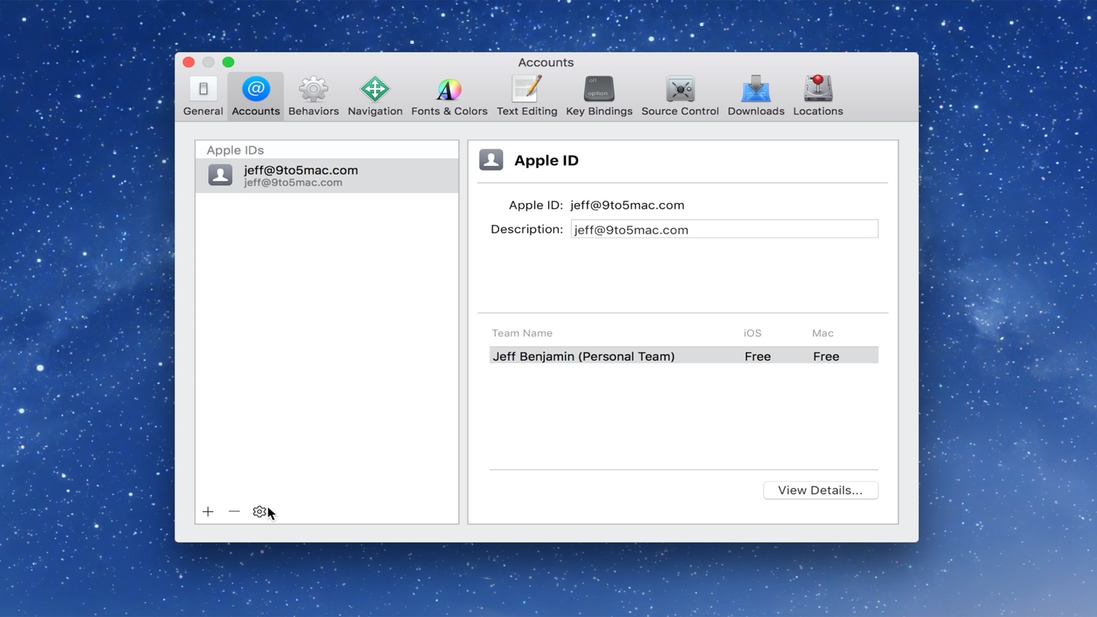

Starting [with Xcode 7](http://9to5mac.com/2015/06/10/xcode-7-allows-anyone-to-download-build-and-sideload-ios-apps-for-free/), Apple made it possible to sideload apps on the iPhone, iPad, and Apple TV using a free Apple ID. Although a paid developer account is still required to deploy apps to the App Store, users wishing to sideload open source apps on a personal device can do so with relative ease. In this post, we’ll show you how easy it is to create a free Apple developer account for sideloading apps using Xcode.

### **Creating an Apple developer account**

**Step 1:** Visit [developer.apple.com](http://developer.apple.com/)

**Step 2:** Click Member Center.

**Step 3:** Sign in with your Apple ID.

* If you already have an Apple ID, you’ll just need to agree to Apple’s Developer Agreement to turn it into a free developer account. Type in your Apple ID and click Sign In.
* If you don’t already have an Apple ID, you’ll need to create one first. Click Create Apple ID, and fill out the required information and click Continue. You’ll then need to sign in with the Apple ID that you just created, and go back to the Member Center.

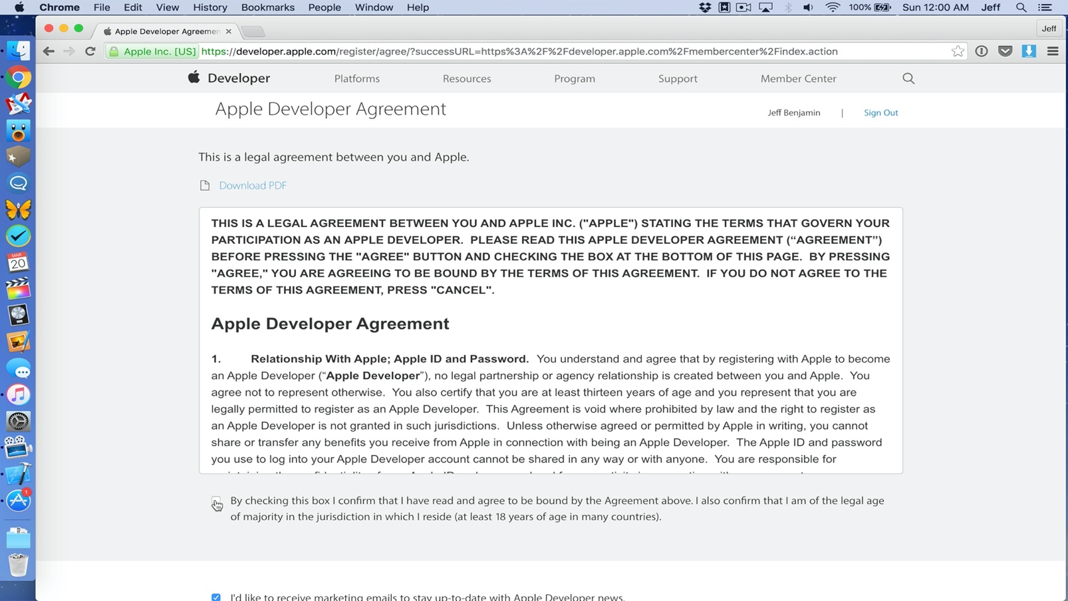

**Step 4:** On the Apple Developer Agreement page, click the first check box to accept the agreement and click the Submit button.

Your Apple ID now works as a free developer account. As stated at the outset, this account can be used for sideloading apps via Xcode. You will not be able to submit apps to the App Store, or download iOS, OS X, watchOS, or tvOS developer betas. A $99/year paid developer account is still required to enjoy those privileges.

## **Video walkthrough**

### **Signing in with Xcode**

**Step 1:** [Download Xcode](https://itunes.apple.com/us/app/xcode/id497799835?mt=12&uo=4&at=11l9Le) from the Mac App Store.

**Step 2:** Launch Xcode.

**Step 3:** Click Xcode → Preferences → Accounts and click the ‘+’ sign and choose Add Apple ID.

**Step 4:** Login with the Apple ID that you just enabled with free developer privileges.

You can now use Xcode to sideload apps on your favorite platforms. This tutorial can also be used in concert with our [Apple TV 4 jailbreak tutorial](http://9to5mac.com/2016/03/23/how-to-jailbreak-apple-tv-4-pangu-1-0-tvos-9-0-and-9-0-1/).

This is a basic tutorial that will be referenced in future tutorials involving sideloading on the Apple TV, iPhone, and iPad. Stay tuned for additional discussion regarding sideloading apps.

## **How to Set-up Your Google Play Developer Account and Google Wallet Merchant Account**

### **1. Go to the Google Play Developer Console <https://play.google.com/apps/publish/signup/> and sign up for an account.**

[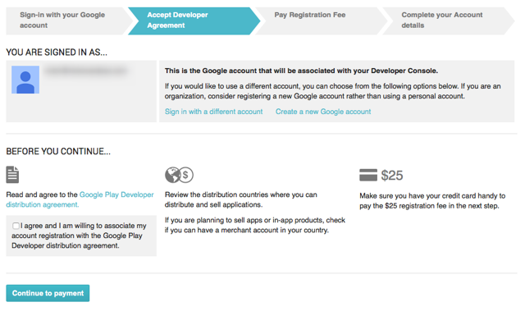](https://s3.amazonaws.com/screensteps_live/images/magplus/171042/1/rendered/03802578-a19a-4279-9129-c57fd17d2800.png)

### **2. Read and agree to the Google Play Developer distribution agreement.**

[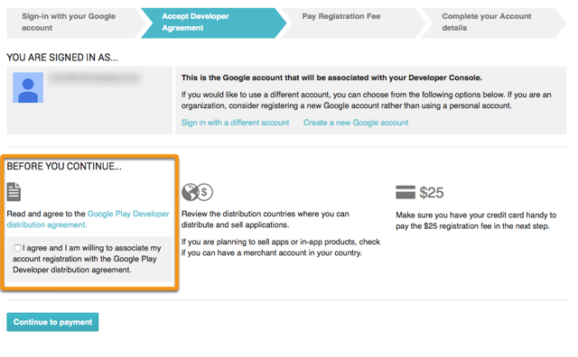](https://s3.amazonaws.com/screensteps_live/images/magplus/171042/1/rendered/7b4c387e-d7d1-4df0-943b-f13cc4365e70.png)

### **3. Pay the registration fee for your account.**

[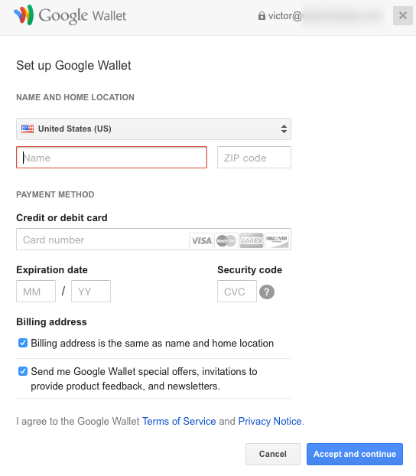](https://s3.amazonaws.com/screensteps_live/images/magplus/171042/1/rendered/76a0cbfc-7ebb-4a93-9500-29801e394558.png)

### **4. Fill out your Google Play Developer Profile.**

[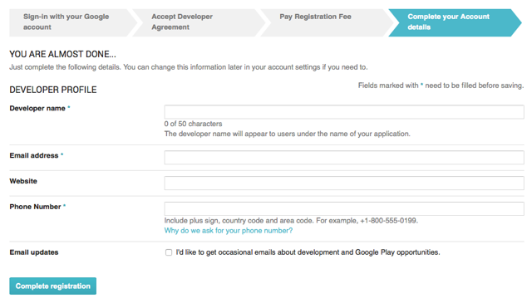](https://s3.amazonaws.com/screensteps_live/images/magplus/171042/1/rendered/019ddc0b-cbc3-43f3-8067-45160ca0ea14.png)

### **5. (Optional) If you plan to create paid apps or in-app purchases for products, set-up a Merchant Account.**

This will prompt you to create a Google Wallet Merchant account. Follow the presented steps to complete your enrollment. You will be directed back to the Developer Console when your account is approved.

[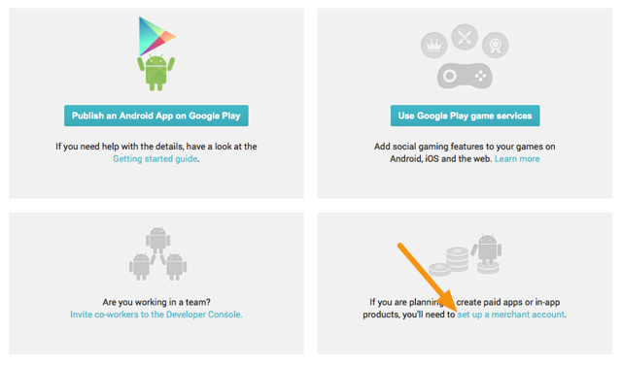](https://s3.amazonaws.com/screensteps_live/images/magplus/171042/1/rendered/39baf615-2ad9-4700-a41d-2901585c004a.png)

### **6. Go to Settings (Label 1) > Merchant Account to access a link to go back to your Merchant Account (Label 2).**

[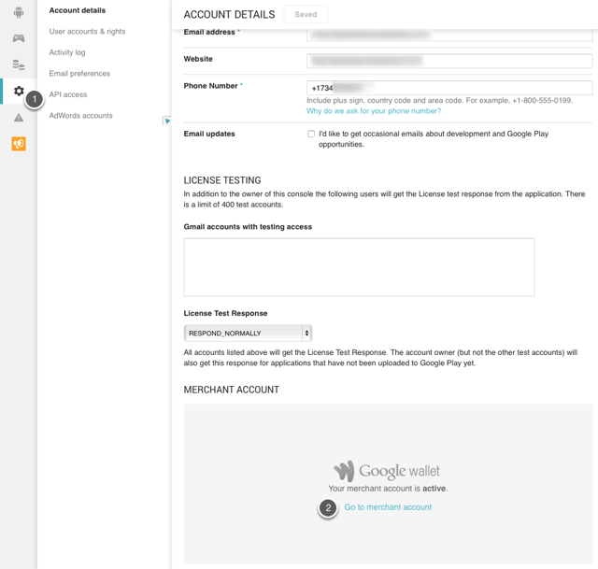](https://s3.amazonaws.com/screensteps_live/images/magplus/171042/1/rendered/96e830b4-7067-4981-936d-103e0820ef86.png)

### **7. In the Wallet Merchant Center, go to Settings (Label 1) > Sales Tax (Label 2) and fill out the appropriate details.**

**Important Information**

* It is vital to set-up the proper sales tax for the geographic regions where you will sell your app. You can learn more about sales tax settings by [reading the Google Help article on charging sales tax](https://support.google.com/payments/answer/3092806).
* For more information on tax rates and value-added tax (VAT), [read the Google Help article on this subject](https://support.google.com/googleplay/android-developer/answer/138000?hl=en&topic=15867&ctx=topic).

[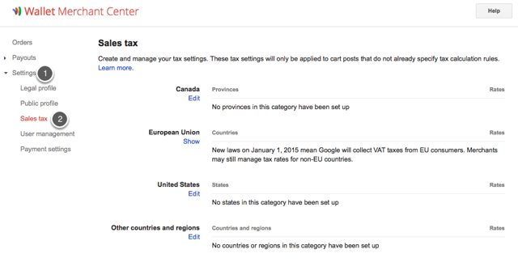](https://s3.amazonaws.com/screensteps_live/images/magplus/171042/1/rendered/62a1cb29-cf3c-497e-b053-b801da17da05.png)

## **App Creation: Next Steps**

Once you've set-up and configured your account, you can create a Google Play app and find your Google Play License Key. This key is tied to your branded Mag+ Android app and is entered in the mag+ Publish portal prior to building your app. [See the article "Android - Creating an App in the Google Play Developer Console" for more information.](https://support.magplus.com/hc/en-us/articles/203808818)